Heaven’s Light is Our Guide

**Rajshahi University of Engineering & Technology**



Department of Electrical & Computer Engineering

|  |  |
| --- | --- |
| Submitted To | Submitted By |
| Tasnim Binte Shawkot  Lecturer  Department of Electrical and Computer Engineering,  Ruet | COURSE NAME : Numerical Techniques Sessional  COURSE NO. : ECE 2214  Name:Tarikul Islam Tamiti  Class: 2nd year even 16 series  Roll No.: 1610001  Session: 2016-17 |

**Name of the experiment:** Find out the real root of the equation f(x)=e^-x – x with the help of Newton Raphson method.

**Program code:**

clc;

clear all

xi=2;

fprintf("i x(i) x(i+1) fx(i) \n");

for i=1:1:100

f_xi=exp(-xi)-xi;

df_xi=-exp(-xi)-1;

xj=xi-(f_xi/df_xi);

xi=xj;

fprintf("%d %f %f %f \n",i,xi,xj,f_xi);

if( f_xi<.0001 && f_xi> -.0001)

break;

end

end

**Output:**

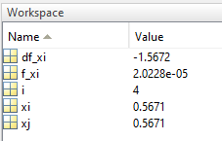

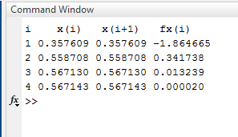

**Discussion:** In this experiment we solve a complex equation very easily using Newton Raphson method. NR method is very useful and the convergence to the root can be done very easily. But one of the main disadvantage of the method is that if the derivative value of the equation is 0 then we can not use it in the NR formula.

**Name of the experiment:** Find out the real root of the equation f(x)=e^-x – x with the help of Secant method.

code:

**Output:**

clc

clear all

x0=1;

x1=2;

fprintf("i x(i-1) fx(i-1) x(i) fx(i) x(i+1) fx(i+1) \n") ;

for i=1:1:100

f0=exp(-x0)-x0;

f1=exp(-x1)-x1;

x2=(x0*f1-x1*f0)/(f1-f0);

f2=exp(-x2)-x2;

x0=x1;

x1=x2;

fprintf("%d %f %f %f %f %f %f \n",i,x0,f0,x1,f1,x2,f2);

if(f2<0.0001 && f2>-0.001)

break;

end

end

Output:

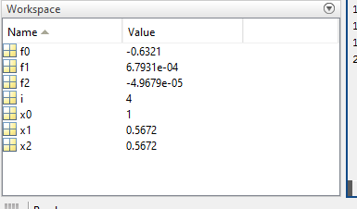

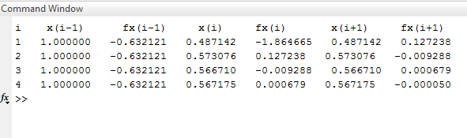

**Discussion:** In this experiment we solve a complex equation using Secant Method. Secant method is a very useful and easy method comparing other methods. The outcomes of the NR method can be easily overcome in this method. The convergence to the root is very fast in this method.